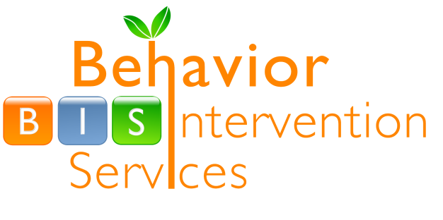
B.I.S., LLC
5389 Arsenal Street
St. Louis, MO 63139
Office: (314) 772-6933
Fax: (314) 772-5858

Activities Calendar
Art Club
11am-12pm & 4:30-5:30pm @ BIS

Come and join in the fun of creating beautiful pieces of art work while meeting new people, practicing social skills, and trying out new things, such as clay, paper mache, painting, tie-dye, and mixed media art!

August 17th – October 5th

October 19th – December 7th

Cost: 1 time fee of $25 for each 8 Week Session

Please contact Beck Swendig at (314)772-6933 of at rswendig@behaviorinterventionservices with any questions.
Fun with Fitness
5-6pm
Meet at Sublette Park for an hour of games,
socializing, health, and fitness and lots of fun!

***FREE!***

Please contact Meghan Halbrook at (314)772-6933 or
at mhalbrok@behaviorinterventionservices.com
with any questions.

October
Thursday 10/6 Tuesday 10/18
Tuesday 10/11 Wednesday 10/26

What: A 5-week course on

When: Every Tuesday & Thursday 6:30-7:30pm

October 4th – November 3rd
Individuals (age 10+) who have developmental disabilities and cognitive delays that need focused classes on staying safe, reporting harm, and advocating for their rights

November 15th – December 22nd
Individuals with a diagnosis of Asperger’s or High Functioning Autism (age 13+) who need classes on sex, sexuality, emotions, dating, sexual health, self- advocacy & safety.

Where: Behavior Intervention Services
5389 Arsenal Street
St. Louis, MO 63139

Cost: $100.00

***Parents & Guardians***

A parent/guardian class is offered every Tuesday at the same time. The cost is $50.00.

Please contact Beck Swendig or Anne Kraus at (314)772-6933 or at rswendig@behaviorinterventionservices / akraus@ behaviorinterventionservices with any questions.

Parent & Guardian Support Group
Who: Parents & Guardians of Individuals with
Developmental Disabilities
What: 1 Therapy session every other week for a
total of 6 sessions
When: Fridays 6:30pm – 7:30pm or Saturdays
1:00pm – 2:00pm
Where: Behavior Intervention Services
Cost: $120 for 6 sessions or BIS may be able to bill
Medicaid in some situations

ISL Parent & Guardian Support Group
Who: Parents & Guardians of Individuals with
Developmental Disabilities living in ISL’s
What: A support group session one time each
month focused on issues associated with
having a loved one living in an ISL
When: 2nd Saturday of each month 2:30 – 4:30pm
October 8th * November 12th * December 10th
Where: Behavior Intervention Services
Cost: $10.00 per person for each session
Both are facilitated by Beck Swendig, LMSW
(314)772-6933 or rswendig@behaviorinterventionservices

Holiday Camp

Come enjoy a week of fun and excitement at BIS Holiday Camp! This is a great opportunity for campers to engage in an array of recreational, arts and craft, and social interaction activities.

Who: Individuals with developmental disabilities (ages 4.5+)
When: December 27th-30th 8:30am-12:00pm
Where: Behavior Intervention Services
Cost: $150

For questions please contact
Rebecca Swendig:
rswendig@behaviorinterventionservices
or Anne Kraus:
akraus@behaviorinterventionservices.com
Both: (314) 772-6933

Social Skills
Who: Children ages 5-12 and 13-18 with high functioning Autism or Asperger’s

What: Provide a supportive and open environment for children to explore different topics of social interaction; including an in-depth curriculum and many opportunities to socialize with peers.

When: Wednesdays, 6:00-7:00pm

When & Where: Each age group will meet every other week for a total of 6 sessions at BIS
Ages 5 – 12 Ages 13 – 18
September | 28th | September | None
October | 12th & 26th | October | 5th & 19th
November | 9th & 23rd | November | 2nd, 16th, 30th
December | 7th | December | 14th

Cost: $120 for 6 Sessions
Glee Club
Who: Individuals with developmental disabilities
What: Come join in the fun singing songs, dancing, and
playing instruments to fantastic music!
When: Thursdays @ 12:30 – 1:30pm
Where: Behavior Intervention Services

***FREE!***

Please contact Meghan Halbrook at (314)772-6933 or at mhalbrok@behaviorinterventionservices.com with any questions
Sibling Support Group – Wednesday Nights 6:00-7:00pm
Who: Siblings age 7 – 12 and 13-18 who have a brother or sister with a developmental disability.

What: Siblings of individuals with developmental disabilities will have the longest lasting relationship with these individuals. Due to this, they experience a lifetime of the ups and downs that come with interacting with and caring for their siblings. The understanding is that the majority of these siblings function in a healthy family. However, they lack friends who understand what challenges they endure on a daily basis, and are sometimes unable or uncomfortable communicating their concerns and struggles. Sibling support groups have found to be a very effective way to not only provide a supportive and open place to express feelings, but also a place to provide a network of same-age siblings.

When & Where: Each age group will meet every other week for a total of 6 sessions at BIS
Ages 7 – 12 Ages 13 – 18
September | 28th | September | None
October | 12th & 26th | October | 5th & 19th
November | 9th & 23rd | November | 2nd, 16th, 30th
December | 7th | December | 14th

Cost: $120 for 6 Sessions or BIS may be able to bill Medicaid in some situations

Girl’s Night, Guy’s Night
Who: Individuals with developmental
disabilities
What: Enjoy fun activities and socializing
with other girl and guy pals!
When: Tuesdays @ 5:00 – 6:30pm
Where: Behavior Intervention Services

***FREE!***

Please contact Meghan Halbrook at mhalbrok@behaviorinterventionservices.com or at (314)772-6933 with any questions

